Project Number 2 Report

Liu Yifu A20307645
Zhao Linghan A20313766

Instructor: Suresh Borkar
ECE485 section 1
Executive Summary
According to project 2, the goal of this project is to provide you with a more practical hands-on approach to computer architecture design problems. I will design a 32-bit version of the MIPS processor. Also, I need to implement the multicycle datapath version of the processor utilizing the VHDL hardware descriptive language.
The total set I design is the core set (lw $t3, 200($s2), sw $t4, 100($t3), add $s3, $t2, $s2, beq $s5, $s2, 500) and a custom set (OR, ANI).
Our goal is to get the instruction set implemented and tested. This project 2 will focus on the implementation of the datapath without the control design.
In this report, I will clearly display the design process of project 2.

Introduction
In project 2, computer low level language VHDL program will also be used as in project 1.
First of all, the first problem is what our CPU can do? The basic features are: load instructions (Load), storage instructions (Store), conditional instructions (Beq), and add (Add) and some simple arithmetic instructions. With these basic functions, then CPU will take data out from memory, and then make the appropriate computing data store back to memory.
Then we will to design the processor to meet the requirements of variety of components. We need one arithmetic logic unit (ALU) to handle kinds of integer arithmetic. Also memory needed to be used to temporarily store the data and instruction. Then we need a register to provide arithmetic sources for ALU and so on. Of course, at last we have to combine all the blocks into CPU and complete the multicycle datapath with states change and control.
Design and Implementation
- Design for ALU
As the ALU design lecture in class, we can figure out that we can use 1bit ALU to create 32bit ALU. As showed in Figure 1, Full 32-bit ALU can be created by connecting the adjacent 1-bit ALU’s.
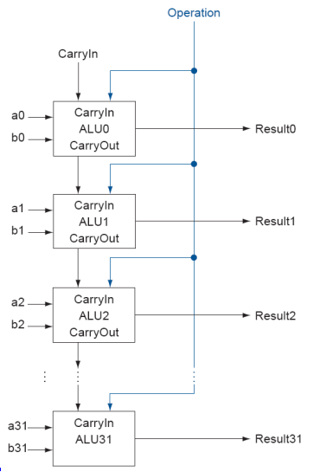
Figure 1

In ALU_bit, we can calculate operation A and operation B to implement functions (LW, SW, ADD, BEQ, OR and ANDI). We should define a select signal to choose which function will be implemented. Then, In the ALU_32bit, we combine the ALU_bit to create 32-bit ALU by each bit.

- Design for Register
We need a register to provide data source for ALU to do arithmetic operation and implement function.
The block of register fine shows in Figure 2
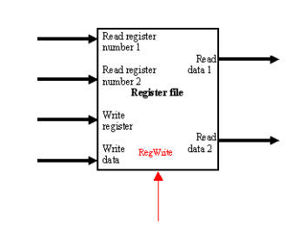
Figure 2
As showing in Figure 2, we know that register internal structure is divided into two parts, read and write. We use the some part of the instruction bits to determine those selected registers and these contents are sent to ReadData1 and ReadData2, so for ALU operations and elsewhere use. We use the Array in this way places with Behavior Modeling can describe register in a very simple way.

- Design for Memory
We use the Array simulated the memory. The simulation machine code that will be executed stores in this memory. Then the CPU can read and execute. In this Memory, every address contains 8 bits source
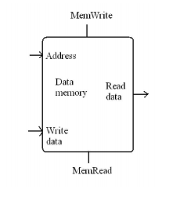
Figure 3
As showing in Figure 3, the memory contains inputs Address, Write Data and output Read data. I use mem_rw to control the read and write of Data memory. In addition, there was only one memory in multicycle CPU, so the instructions and all operation data are put in the memory together.

4. Design for Multicycle Datapath
The multicyle CPU will combine all the blocks we just talked about. ALU, register and memory are all used to create this multicycle processor. In the VHDL code, Components about ALU32, MEM and REG will be added to construct the CPU which shows in Figure 4.
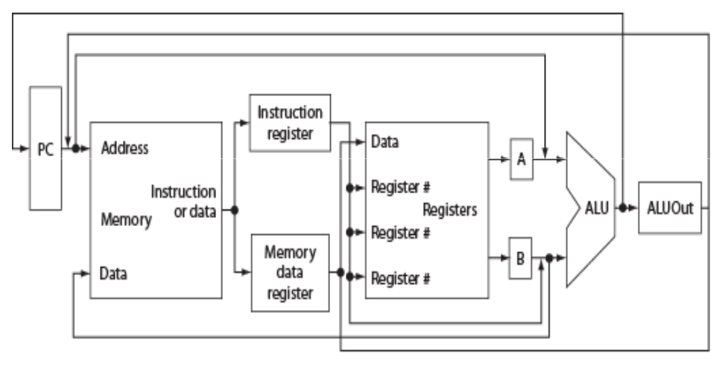
Figure 4

Additionally, we start to create the multicycle datapath with different states. With these defined states, we can control and implement the datapath to process our instructions. The finite states diagrams shows in Figure 5.
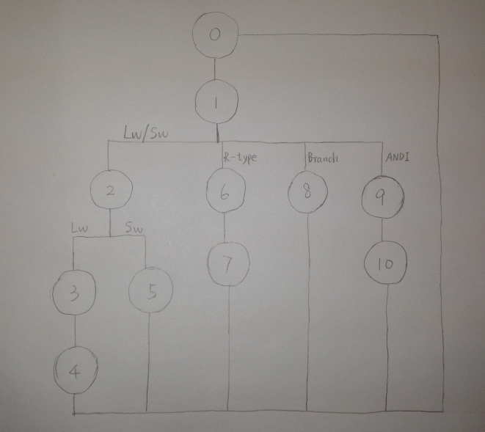
Figure 5

In the states diagram, we just consider basic instructions and our custom set. So we define states in a simple way to clarify every instruction.

Discussion
1. How do we try to optimize your design?
At first, we want to use loop (VHDL FOR cyclic sentence) to create 32-bit ALU, but it does not work as carry_in and other signals are not considered in the ALU combination. So as lecture professor discuss in class, we use one bit to combine a 32-bit ALU and try to consider thoroughly.
In the MUL_CPU file, we use clock cycle to control to let each state change to next state. So the five stages of an instruction will process as the clock cycle and state change. The multicycle datapath seems more obvious in the waveforms.

2. Improvement about our design
In the combination of CPU, we add the states change in the same part. So we will simplify our code design as easy control unit and distinguished states. We separate ANDI and OR from ADD and R-type instructions, so the instruction will easily find their states to implement the function, and then achieve the result.

3. Problems and solution in our design
Memory contains the values has some problems. Because we just have one memory and we can not separate the data and instruction in this memory. So there is some problem as the operation A and B will get the value of instruction number. Our solution is to fix the value to the operation to make them constant. Then we will implement different functions with constant data.
Another problem is that reg_in signal and mem_in signal do not get values. However, we have set the value to them from mem_out and reg_out which both have values. Till now, we can not solve this problem.

Result

Conclusions
All VHDL files compile correctly and signal values in MUL_CPU are accurate. Project 2 provides us a precious chance to review all the knowledge of CPU and more familiar with VHDL language. However, my partner and I encounter a lot of questions in the project; for example, we have no idea how to create a 32-bit ALU that combined by 1-bit ALU and how to change the state to implement our instructions. Finally, I compile files successfully and simulate to get waveforms.

